The Gaia Deception

Collectivism, Communitarianism, the Collective Consciousness.

All drivers of global acquiescence into the new technocratic happy clappy, feelgood genocide.

The NGOs and think tanks that drive corporate global change decided that collectivism and a common enemy
would be the best driver

The club of Rome in their First Global Revolution stated that In the absence of war , famine and the like global warming would fit the bill, all these are caused by man so the common enemy of mankind is mankind itself

A new form of original sin carbon taxation and depopulation

The earth religion was central and the voice of the earth mother was even channelled,
The Aquarian Conspiracy was a front for collective immersion into the new global cult

The updated Celestine Prophecy, the same cult

The Rainbows being put everywhere are a sign of aquiessence to the new system and The Noahide laws,

the same as mask wearing is a sign of compliance with the new slave system,

The Earth has been hijacked by land pirates who are saying we should be evicted

Only a lucky few will remain, those that agree to be genocided will go first.

There will be food shortages, artifical scarcity of all kinds to re emphasize the point that there are too many on the planet

Those who do not take part in the smart fluffy genocide will stand a good chance of survival.

The globalists hide out in rich areas and need compliant fools to do their dirty work.

Look around you, how many compliant fools do you see?

Putting the recent -past in line with the present:

The Covid Action Plan is all part of New Age Global Governance

The New Age is a management system

Its main aim is population reduction and a compliant population

The UN is the mentor of the New Age: Madame Blavatsky, Alice Bailey.

Their whole population reduction plan came from the likes of them.

Alice Bailey and her husband Foster set up the Lucifer now known as the Lucis Trust in 1924.

The Lucis Trust has seats at the UN and its Great Invocation invites the new Maitraya.

The main driver of New Age Governance at the UN was Robert Muller

Robert Muller created a "World Core Curriculum" and is known throughout the world as the "father of global education."

Robert Muller was born in Belgium in 1923 and raised in the Alsace-Lorraine region in France

He spent his whole life in senior positions in the UN

and also behind the scenes at the United Nations focusing his energies on forming a world governance system through the UN

His Bio says:

He rose through the ranks at the UN to the official position of Assistant-Secretary-General.

He has been called the "Philosopher" and "Prophet of Hope" of the United Nations.

Robert Muller is a deeply spiritual person.

From his vantage point of a top level global states-person he has seen a strong
connection between spirituality and the political/cultural scene.

The cliché of science and spirituality was how the new governance system justified global totalitarianism presented
in quantum science cliches, latched onto by word salad charlatans and new age gurus such as Deepak Chopra.

The acquiescence to the new system is described as the Lostness of the Mind and The Fourth World Wilderness.

The lead up to the Rio Conference of 1992 and its steering into the system of sustainable development
all starts with the belief that a global elite want to drastically reduce population.

The UN and its agencies were described by Muller as “The birth of a Global Brain for humanity”

Whether Muller’s intention was mass depopulation using biological and psychological tools of warfare is
actually not that important.

He spawned the partaking in a collective genocide through a phoney Earth religion which is now being played out.

Following Muller was Maurice Strong who also used the new age to channel his globalist objectives including the
destruction of western democracy and depopulation.

In a paper released in 2005 called One Earth Rule Muller lays out his vision for what was to become a tool of mass deception for the UN. Their creation of the IPCC to control data on the new Gaia religion of climate change to drive
totalitarian policies and the agencies of the UN such as The IMF and World Bank have all conspired to control the world
through the a new form of original sin and the fake cult created to worship Gaia. In this document Muller even speaks on behalf of the planet

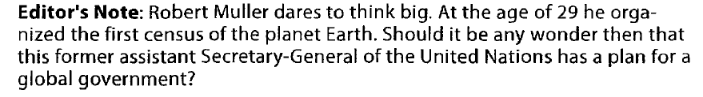
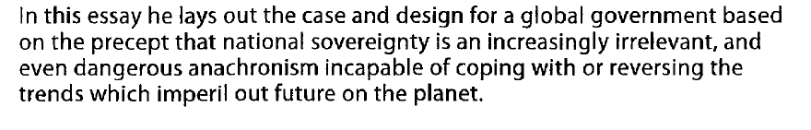
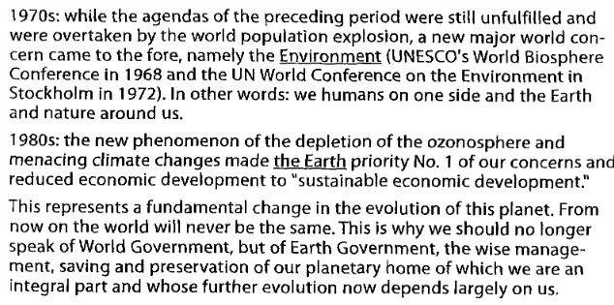

Global Education in to the New Age through the UN was in a big part in their Agenda 21 and 2030

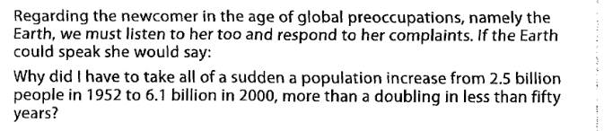

The imaginary conversation continues for several long paragraphs.

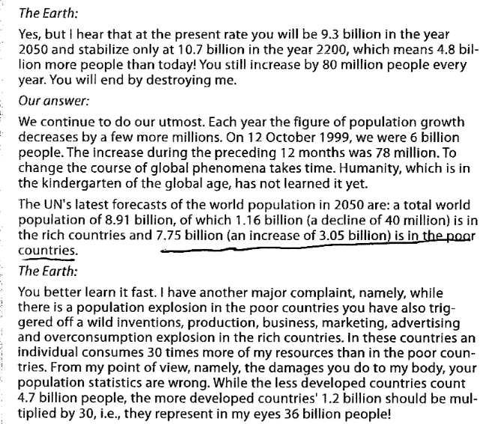

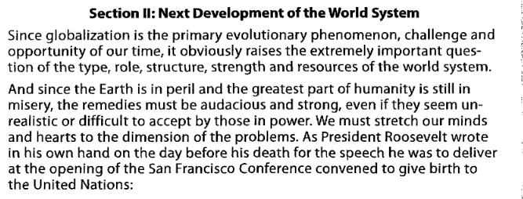

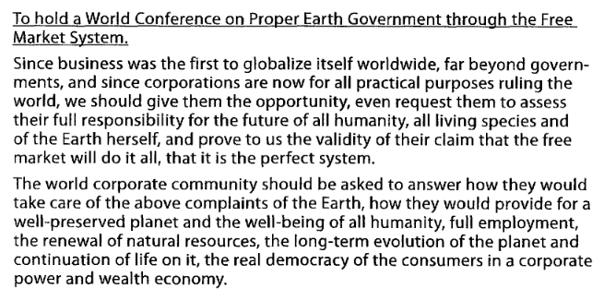

A World Conference on Earth government on what the world's religions have in common in terms of universal spirituality and worldwide human experi-ence

So what came out of this was in fact a technocratic system of population
reduction and strict management on the assumptions of a few

When Roberr Muller and Maurice Strong are examined for what they are, then the whole
illusion of the carbon cult and gaia religion is exposed. Muller was obsessed with depopulation and mixed up
philosophies from the east which were westernised for easy consumption and ideologically subverted into
a communitarian trap. The accepted opinion corridor of sustainability, which in reality means the end for most human life.

Muller may have been idealistically driven but his ideas have become what is a corporate run system above national governments and implementing mass depopulation through the present driver of Covid and its vaccination plan.

This is the result of what he wanted but it is tyrannical and run by criminals.

Maurice Strong fled a wanted criminal and died in China.

He was in some ways a genius and the founder of the UNEP and like Muller in command at the top.

Strong and Muller have created a globalist corporate driven pillaging of all assets of all people

God given inalienable rights stripped away through a fake environmental plan which never had anythin g to do
with the environment. Just an asset stripping control system which is now tightening its grip on the planet.

It is now easy to see the result of the mentoring into the wilderness of the mind.

The acquiescence model of new age acceptance is a mind virus. Lambs to the slaughter and a few wolves dressed as sheep doing the dirty work of the World bank and IMF and of course all the agencies of the UN all above international law

The cult of sustainable development is a contradiction and has nothing to do with what its believers think

Its a lot like Covid, a driver of change

It is nothing to do with the environment but a control system which benefits a tiny few at the expense of
the god given rights of the rest.

